Andrew Lan, Chih Yun Lu, Seung Hwa Lee, Soobin Lim, Jikun Liu, Tarea Karunaratne, Sam Zierler

Applied Data Science, CUSP-GX 6001 - Project Report

Prof. Stanislav Sobolevsky, Richard Vecsler

May 3rd 2022

**Automated Law Enforcement and Its Relationship with Traffic Violation Using NYC as An Example**

**Abstract**

This project focuses on finding the relationship between the presence of automated law enforcement, such as speeding and red-light cameras, and the frequency of corresponding traffic violation incidents. Our goal is to present a case for the increase in availability of traffic cameras, as a means of reducing incidence of traffic violations. To do this, multiple datasets of automated law cameras and traffic violation incidents were compared by observing the indicators' temporal activities and analyzing their fitting to traffic violation cases. Moreover, the impact of increasing the number of cameras and the number of police officers across the city was also compared. We hypothesize a correlation between the prevalence of automated law enforcement and the frequency of violations, and that they will have an inverse relationship, where an increase in the number of cameras would decrease traffic violations.

**Introduction**

Automated law enforcement for traffic safety was piloted in 2013 by the Department of Transportation (DOT) and has steadily grown in the years since. At first, the project had merely 20 cameras located in school zones, but it has now expanded to include over 750 cameras placed in school zones across the city. This program has been identified as being the cause of a significant drop in traffic violations in school zones over the 9 year period since its inception. The provisions made by the DOT for the placement of cameras follows that cameras may be placed in a quarter mile radius of any school building, and may be active between 6AM and 10PM, giving priority to school zones where high incidence of traffic violence has been reported.[1]

The Vision Zero Plan, enacted in 2013, under which initial provisions for automated law enforcement were made, aimed to completely eliminate both traffic deaths and serious injuries by targeting speeding. Speeding remains a major cause of crashes in New York City, with traffic deaths in New York City rising to their highest levels in eight years in 2022. During town halls and workshops held by the DOT and the NYPD, speeding was repeatedly reported as a key concern of citizens and officials, alike, leading to the special provisions being made under the plan. It was found that about a quarter of casualties from speeding violations in 2022 occurred on highways and the remaining three quarters occurred on local streets. New York City has seen a major push for an increase in traffic safety initiatives, including a proposed plan to erect billboards targeting speeding in key areas, and Mayor Eric Adams’ promise to expand the targets set by the Vision Zero Plan.[2]

The city’s speed camera program was implemented by Governor Andrew Cuomo and uses the same radar and laser technology used by the NYPD to track speed, with fines ranging from $90-$600. The implementation of these cameras has caused a 2.7% drop in total crashes, with an additional 8% drop in crashes with injuries, and a 13.9% drop in total injuries, including those involving motor vehicle occupants, pedestrians, and cyclists. The purpose of this report is to understand this impact and make provisions for increasing placement of speeding cameras across the city.

**Literature Review**

When considering the effect of automated law enforcement on driver behavior, it is important to consider the impact of reckless or dangerous driving. A landmark DOT report in 2021 found that nearly 30% of all road fatalities occurred in speed camera zones during times they were turned off. In the 2019 fiscal year alone, the NYPD issued over 11.4 million parking tickets. Of these parking tickets, around 39% were contested, and around 11% eventually dismissed.[3] The DOT case also found that, after expanding cameras to school zones, there was a marked decrease in speed violations, of around 45%, in an 18 week period, as well as an average daily decline in the key school zones, of somewhere between 81-89%. This indicates that the presence of automated law enforcement has a significant impact on driver behavior, and that expanding placement of cameras may have a greater effect. Keeping in line with trends noticed in 2019, several news outlets reported that Governor Andrew Cuomo’s shelter-in-place order had little to no effect on the number of ticket issuances, specifically for essential workers, and delivery truck drivers within the city.

**Data**

**NYPD B Summons (Historic)**

Accessed from the New York City Open Data Portal, and documents the issuance of moving violations (B summonses) by the NYPD. The data is collected from members of service and represents a summons, also known as a violation. The dataset includes data on type of violation, violation date, and time from 2018 to 2020.

**NYPD B Summons (Year to Date)**

Accessed from the New York City Open Data Portal, and documents the issuance of moving violations (B summonses) by the NYPD. The data is collected from members of service and represents a summons, also known as a violation. The dataset includes data on type of violation, violation date, and time from 2020 to April of 2022, and is updated regularly.

**Violation Code**

Data provided by the New York Department of Motor Vehicles, which outlines the type of traffic violation, and its associated violation code. This data provides information on how a violation code is registered, and also how it may be written on an issued ticket.

**Speeding Cameras Tickets**

Data accessed from the New York City Open Data Portal, and provided by the Department of Finance (DOF). This dataset provides information on speeding tickets issued by the state of New York, specifically caught by traffic cameras. The data includes the summons number, the violation code, the violation location, and the issuing precinct.

**DOT Camera Location**

Accessed from the New York City Department of Transportation Website, with data also provided by the DOT. This dataset provides real time traffic information, and also provides the location of every traffic camera in the city, as well as their status as either active or inactive.

**Methods**

*Data collection and cleaning*

In the process of data collection and cleaning, we first filtered NYPD B summons data by violation code 1180 C and five boroughs in New York City. Violation code 1180C represents speeding violations within school zones, and filtering by borough allowed us to refine data for entries only within New York City. From NYC open parking violation data, we used code 36 which is speeding violations in school zones caught by cameras issued by the department of traffic. Although we did not run into any significant issues in the process of data collection and cleaning, we ran into issues in inconsistent labeling between datasets, specifically with borough names. Where some datasets would label the Bronx as BX, others would label it as Bronx County, etc. so a significant amount of time was dedicated to making sure that all the data was consistent and could be used in analysis. Additionally, we have found some sources of key data incomplete or inconsistent. Datasets for some parts of the city were more complete than that of others, and data would often have to be accessed individually and merged together. Additionally, as this is a fairly new project, with data only dating back to 2014, there was a lack of data availability on the same scale of NYPD data.

*Temporal Analysis*

A temporal analysis was conducted on red light violations caught by traffic cameras both by day and by month from the period 2018 to 2021, as can be seen in Figures 1 and 2. The same analysis was then conducted on red light violations caught by NYPD officers in the same period, which can be seen in Figures 3 and 4. The purpose of this analysis was to look at both the volume of violations caught, and to understand if there were any seasonal or temporal trends which could be identified, in line with our hypothesis, or if we could notice any significant increases or drops in violations caught.

*Trend/Density Analysis*

Figure 5 shows the location of cameras across the city as of 2022, with the yellow points standing for live cameras, green points for speed cameras, and the red points for red light cameras. Figure 6 shows the location of red-light cameras specifically. As Figure 14 demonstrates, density analysis was conducted on all five boroughs. The graphs were normalized with data mean, so the curves represented here are not absolute values, rather representative of overall trends in how violations are caught by both humans and cameras. We also assessed the volume of red light violations caught by both NYPD officers and cameras across the city in the year 2019, and scaled the circle size to the number of violations caught at each location.

*ARIMA and Augmented Dickey Fuller Test*

ARIMA and ADF tests were conducted to understand the differences between violations caught by both humans and by cameras, specifically for speeding violations. The ADF test returned that the dataset was stationary for humans as the p-values were all returned as 0. The results for the camera caught violations were not stationary, but became stationary after a 1st order differencing, so the degree of differencing selected was D=1. The SARIMAX test was also run, with the parameters (1,1,1), which could be read as being well fitted as all P-Values were below 0.1. The MA term selected was P=1, where autocorrelation showed the sharpest drop at lag 1, and partial autocorrelation showed the same, with a drop at lag 1, so the AR term was also selected at Q = 1.

**Results**

We found that trends were similar among boroughs for both NYPD violation issuances and those caught by cameras. This implies that overall law enforcement for traffic violations is reasonably consistent throughout New York City.

We may observe that the trends for humans are relatively random, which is evidenced by ADF test results. As the dataset for human caught violations was stationary without differencing, it indicates that the data was considerably random, has a constant mean, and most likely has no seasonal differences.

We also found that all trends for cameras experienced a spike in September 2019, this is most likely owing to a broad increase in the number of cameras placed in school zones, as part of provisions made by New York City’s Vision Zero Plan in June 2019. We also observed that the trend of overall traffic violations over time was trending upwards, indicating that traffic violations increased, especially since the pandemic.

In respect of densities, it is important to consider that the density graphs presented are normalized with mean data, so the curve on the chart does not reflect the absolute values of datasets but merely trends. As Manhattan has a higher density than other regions, with 1.003, when compared with other boroughs such as Brooklyn which has a density of 0.889 or the Bronx which has a density of 0.579, the dataset from Manhattan showed a considerably smaller spike than other boroughs. This is presumably because Manhattan was targeted in the early development of the Vision Zero plan, and as such had a higher number of cameras implemented at the start of the project, so the number of violations caught due to an increase in cameras would be smaller.

Additionally, in looking at the data from Staten Island, which saw a similarly small spike in violations caught, we can assume the opposite effect, whereas the density of cameras is 0.160, there was not a significant increase in cameras placed, and as such no noticeable spikes could be seen. This suggests that there is a noticeable correlation between the number of cameras and traffic violations in the region.

**Conclusions**

In conclusion, it is evident that there are correlations between the number of cameras in a region, and the corresponding number of traffic violations, particularly in Manhattan, Brooklyn and Bronx, as concluded from our trend analysis. While the temporal changes observed during our period of interest are minimal, it is still relevant to note that the presence of traffic cameras in key areas does act as a deterrent to traffic violations, as evidenced by the data. Through this analysis, we are able to make the suggestion that increased placement of cameras in key areas can work to reduce the impact of traffic violation-related incidents, when implemented together with other strong policies, such as the expansion of the Vision Zero Policy.

**Tables & Figures**

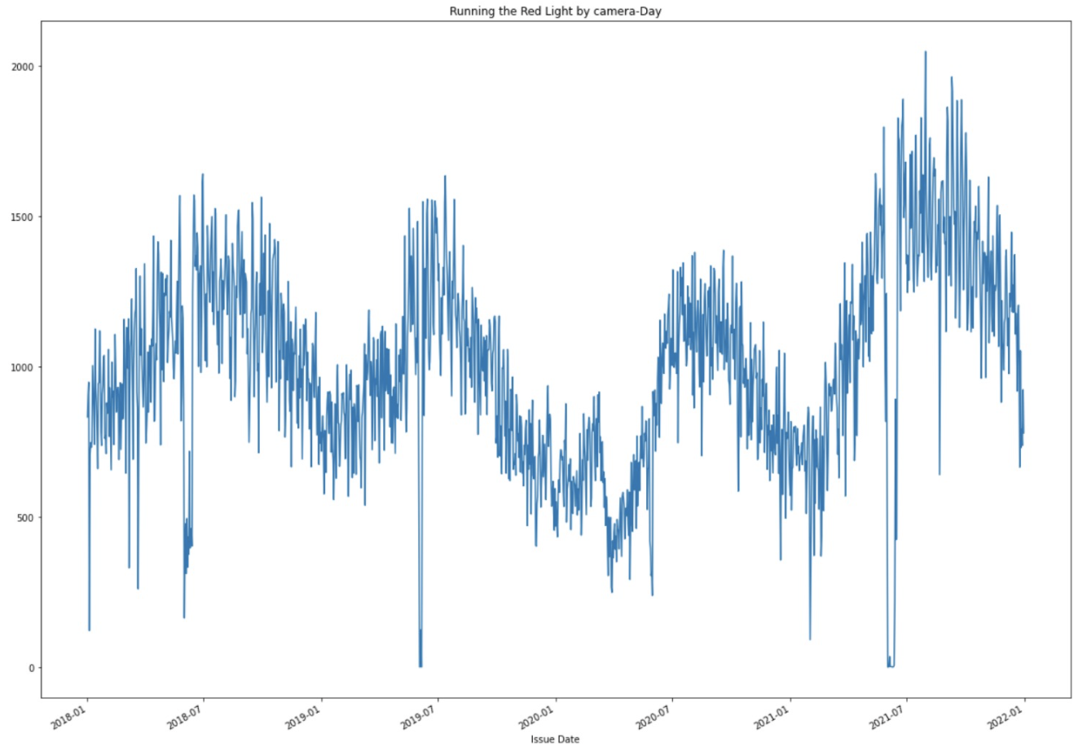

(Figure 1: Running red-light caught by cameras-day)

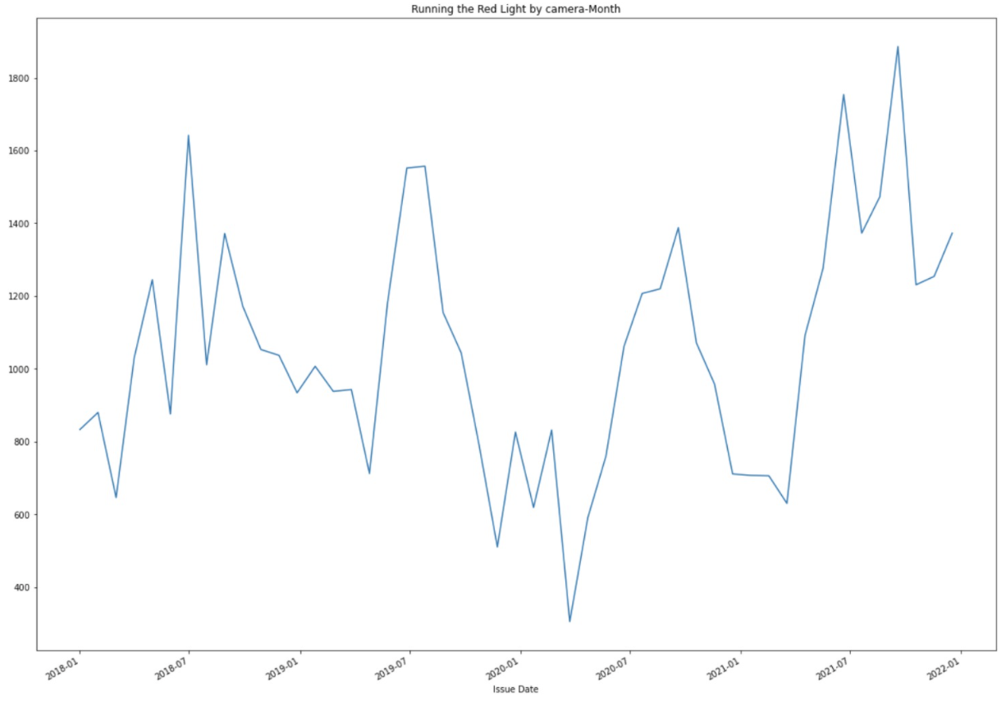

(Figure 2: Running red-light caught by cameras-month)

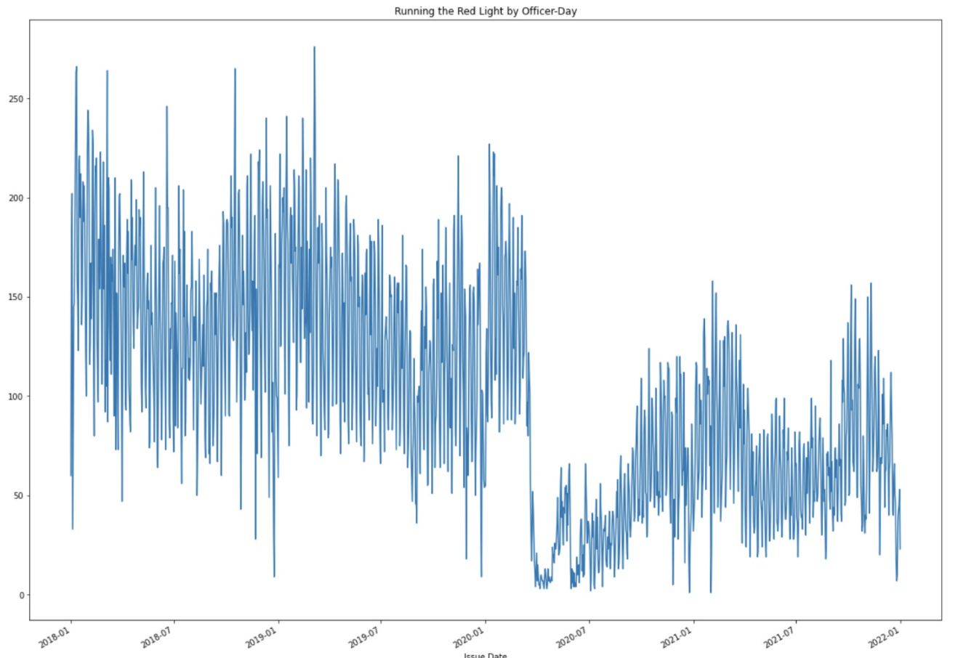

(Figure 3: Running red-light caught by officer-day)

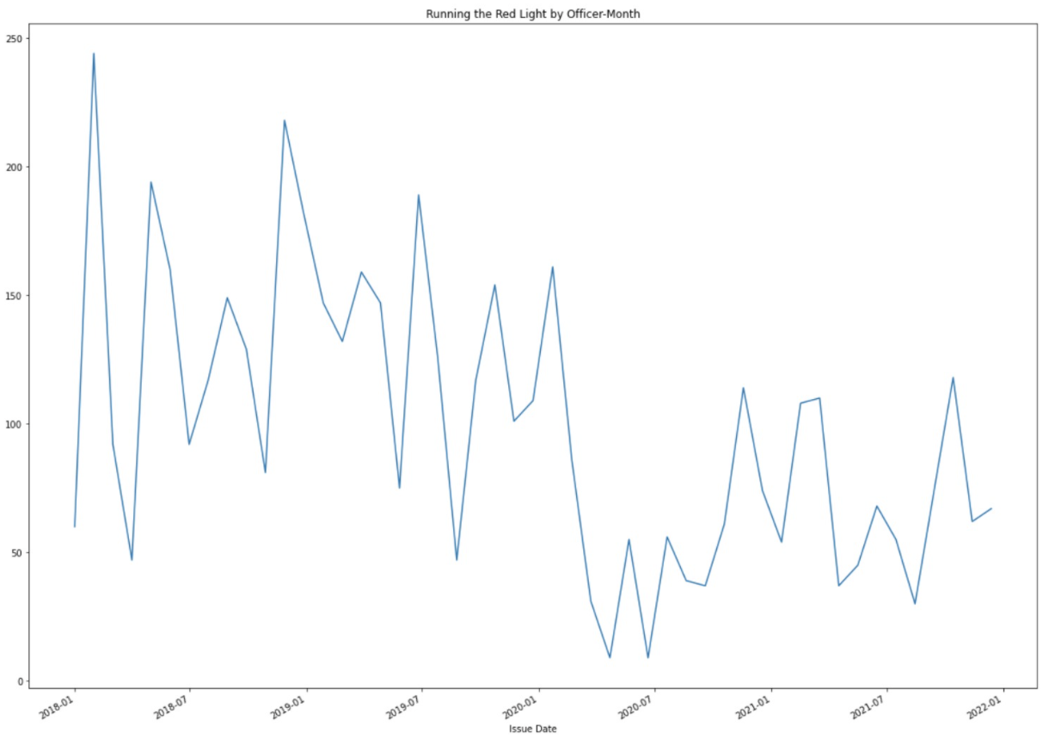

(Figure 4: Running red-light caught by officer-Month)

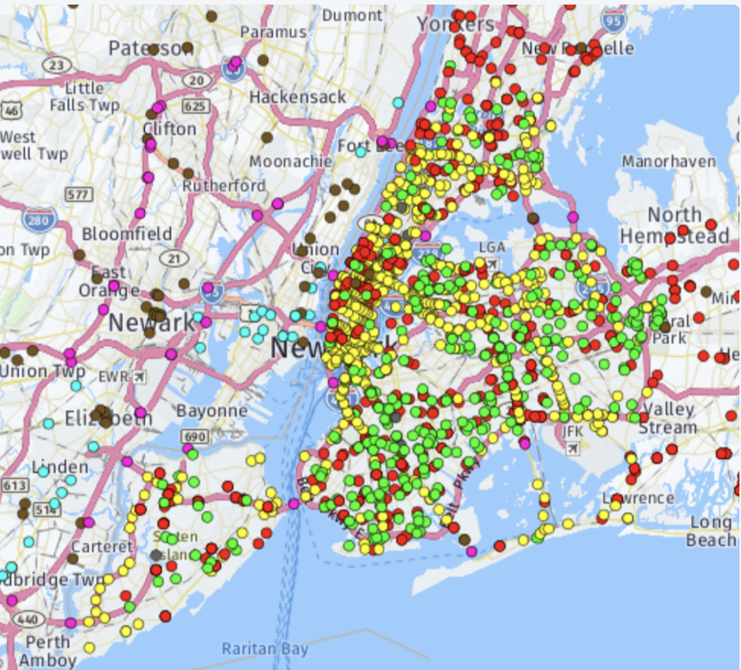

(Figure 5: Location of city cameras)

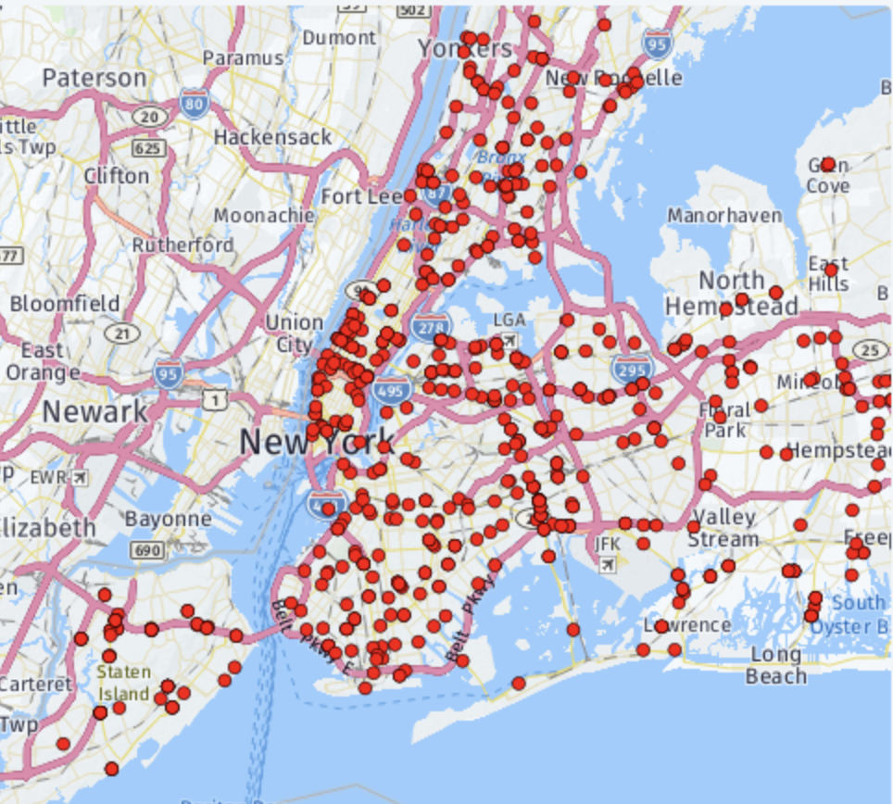

(Figure 6: Location of red-light cameras)

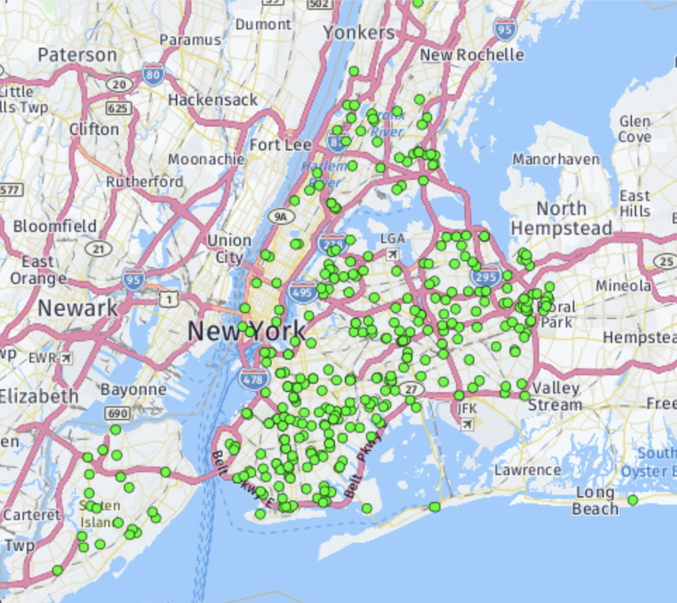

(Figure 7: Location of speed cameras)

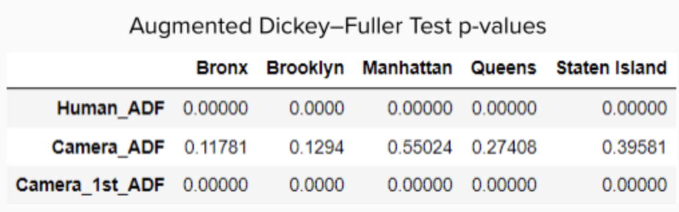

(Figure 8: Augmented Dickey Fuller Test)

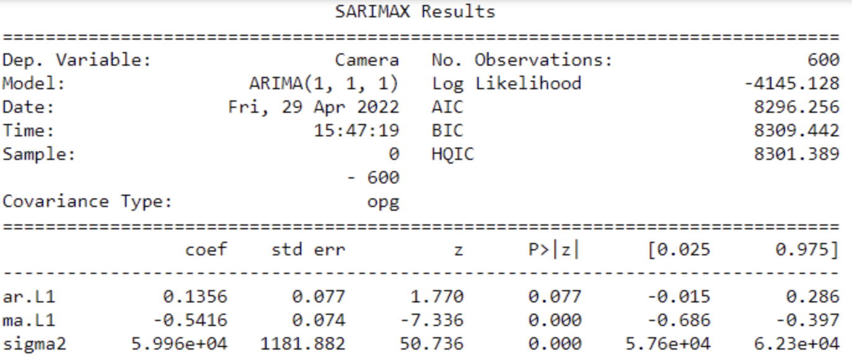

(Figure 9: SARIMAX Results)

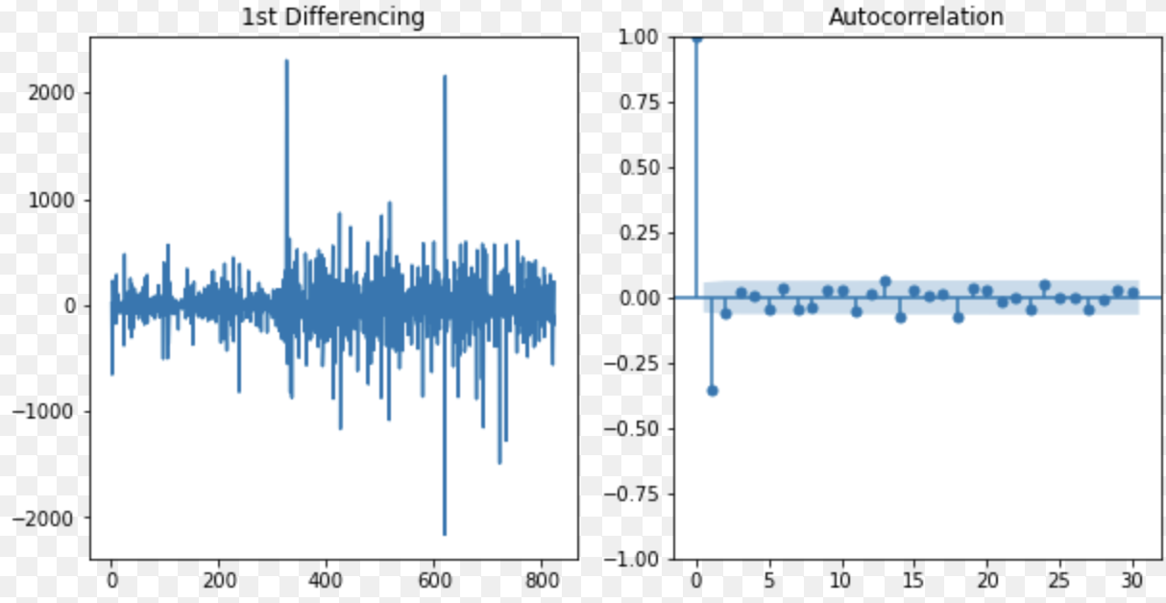

(Figure 10: ARIMA test)

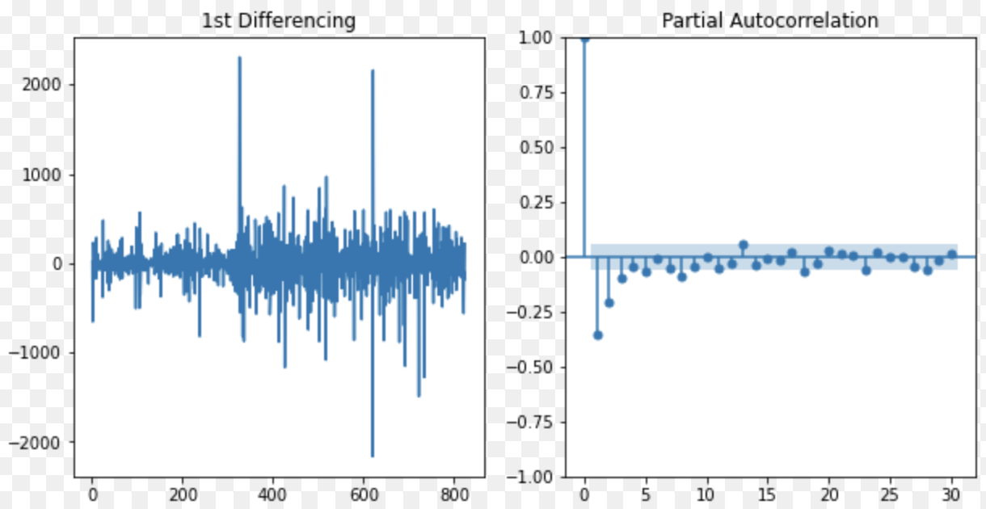

(Figure 11: Results for Partial Autocorrelation)

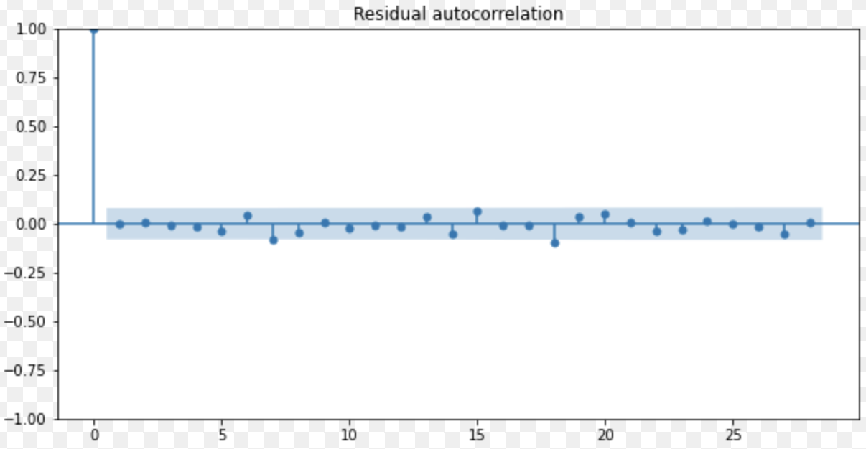

(Figure 12: Results for Residual Autocorrelation)

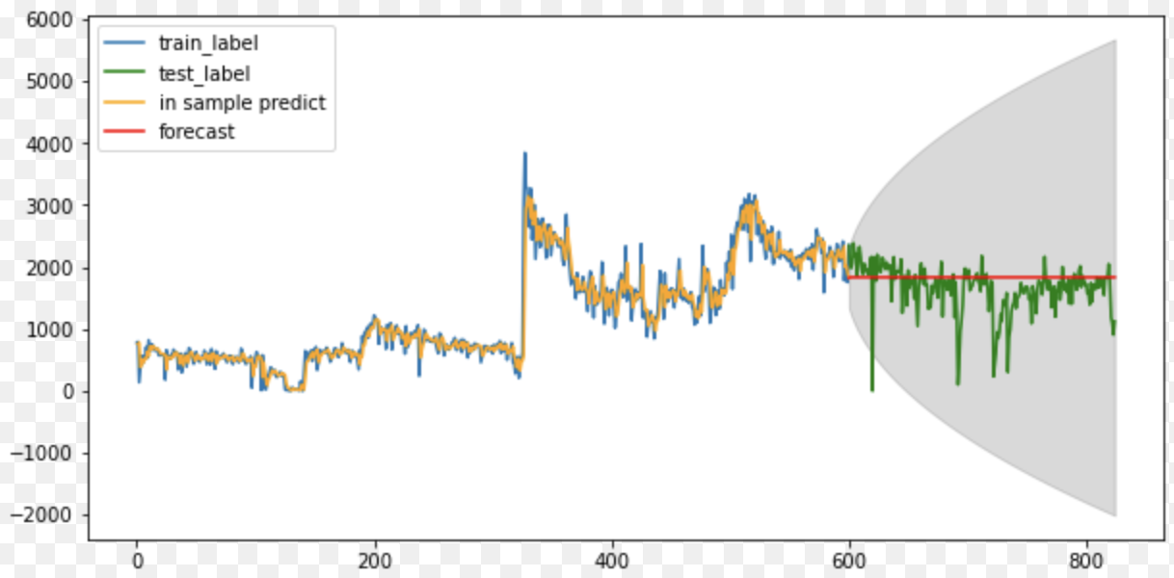

(Figure 13: Prediction)

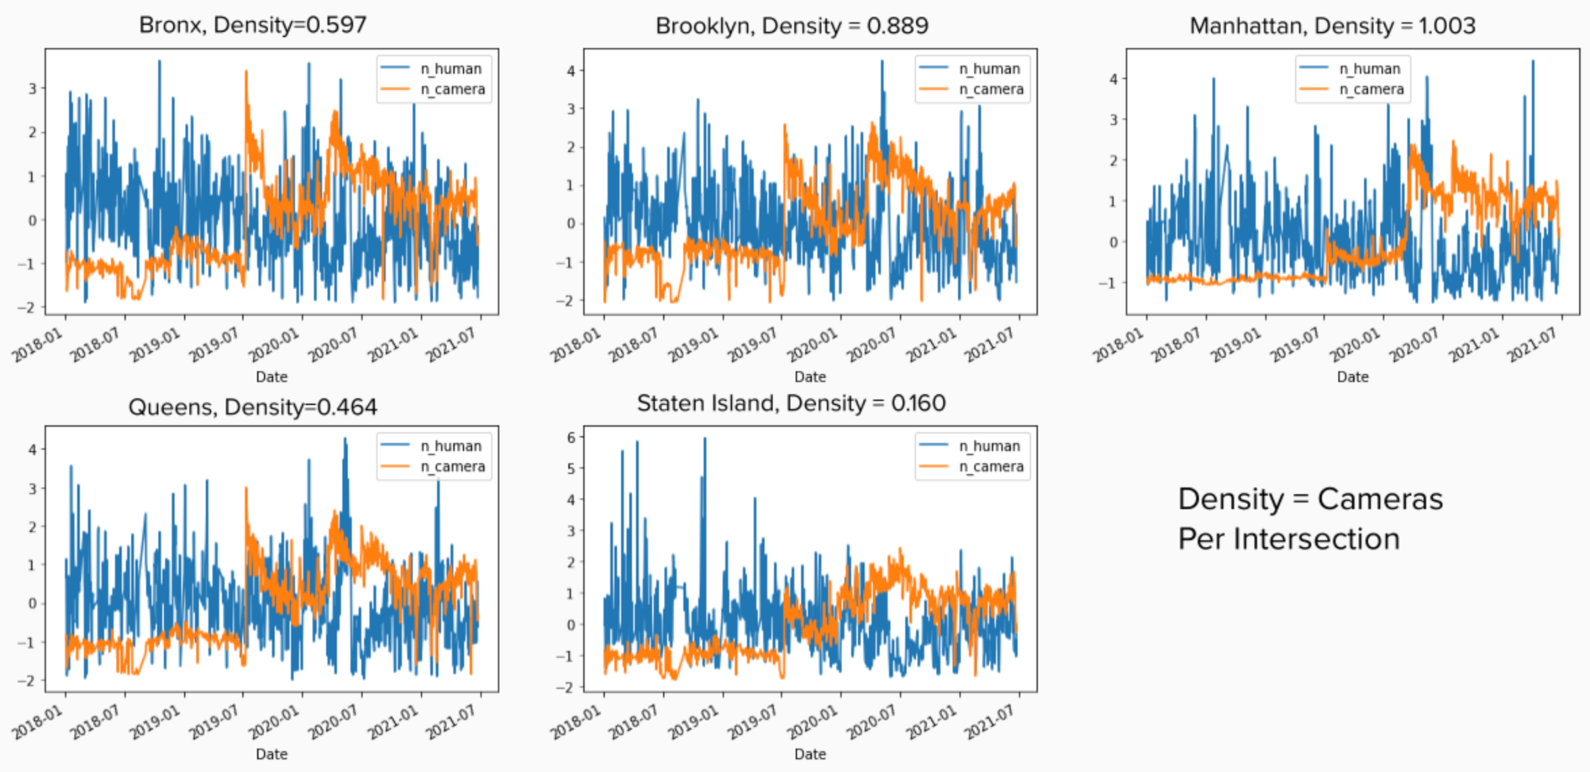

(Figure 14: Trend Analysis)

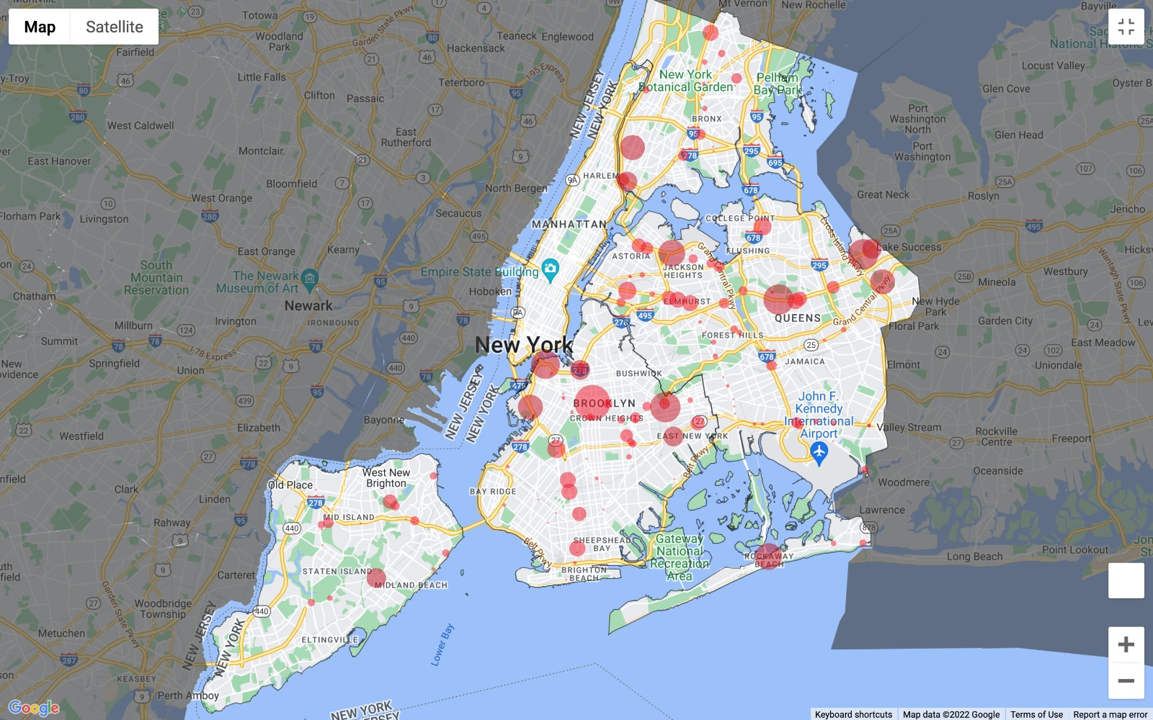

(Figure 15: 2019 Red light violations caught by cameras)

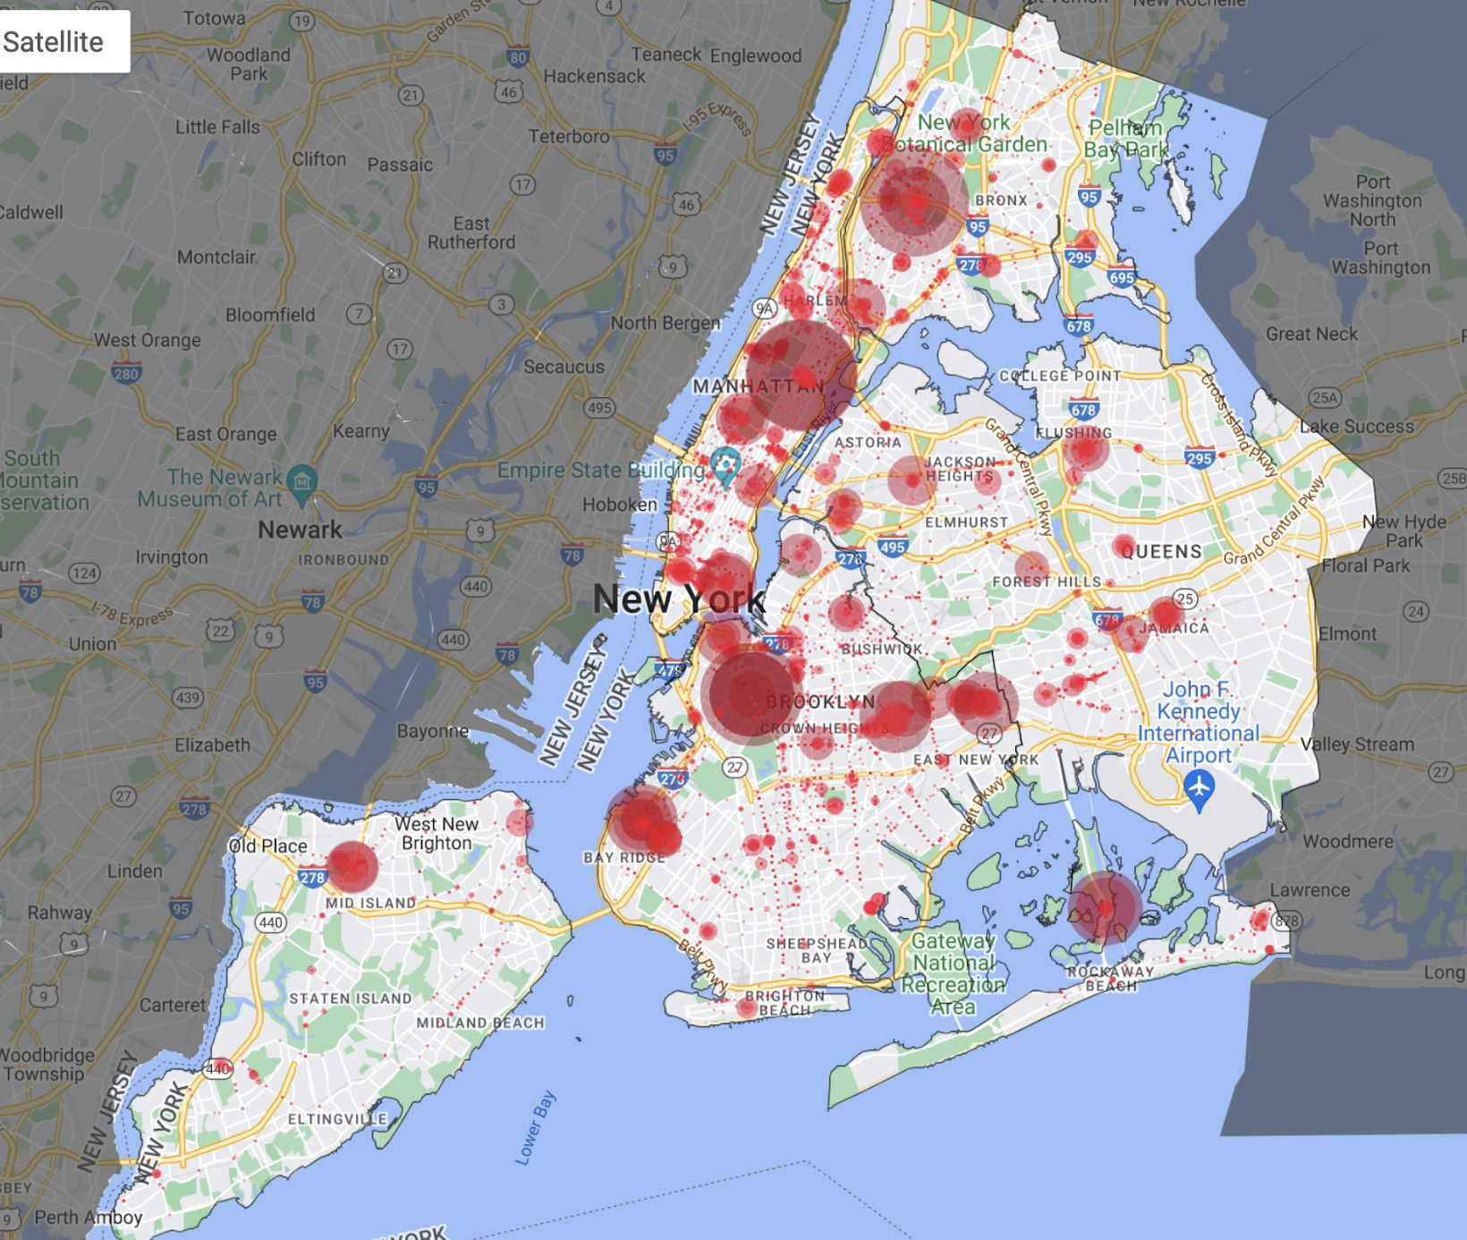

(Figure 16: 2019 red light violations caught by NYPD)

**References, appendixes**

Speed Camera Report - Welcome to Nyc.gov | City of New York. https://www1.nyc.gov/html/dot/downloads/pdf/speed-camera-report.pdf.

Hu, Winnie. “How to Stop Speeding Drivers? Scare Them.” *The New York Times*, The New York Times, 2 May 2022, https://www.nytimes.com/2022/05/02/nyregion/nyc-speeding-traffic-deaths.html.

Schorr, Ben, and Dan@appwinit.com. “62% Fewer Parking Tickets Issued in NYC Due to Covid-19 Quarantine.” *WinIt App*, 14 Oct. 2021, https://blog.appwinit.com/62-fewer-parking-tickets-issued-due-to-during-quarantine/.

New York City Department of Finance.(2017) Speed Camera Tickets [Data file]. Retrieved from <https://data.cityofnewyork.us/City-Government/Speed-Camera-Tickets/3nky-hkft>

New York Department of Motor Vehicles. (2022) Violation Codes [Data file]. Retrieved from <https://dmv.ny.gov/e-data/violationcodes.xlsx>

New York City Department of Transportation.(2022) Speed Camera Locations [Data file]. Retrieved from <https://webcams.nyctmc.org/multiview2.php>

New York Police Department (NYPD).(2022) NYPD B Summons (Historic) [Data file]. Retrieved from <https://data.cityofnewyork.us/Public-Safety/NYPD-B-Summons-Historic-/bme5-7ty4>

New York Police Department (NYPD).(2022) NYPD B Summons (Year to Date) [Data file]. Retrieved from <https://data.cityofnewyork.us/Public-Safety/NYPD-B-Summons-Year-to-Date-/57p3-pdcj>

1. *Speed Camera Report - Welcome to Nyc.gov | City of New York*. https://www1.nyc.gov/html/dot/downloads/pdf/speed-camera-report.pdf.
2. Hu, Winnie. “How to Stop Speeding Drivers? Scare Them.” *The New York Times*, The New York Times, 2 May 2022, https://www.nytimes.com/2022/05/02/nyregion/nyc-speeding-traffic-deaths.html.
3. Schorr, Ben, and Dan@appwinit.com. “62% Fewer Parking Tickets Issued in NYC Due to Covid-19 Quarantine.” *WinIt App*, 14 Oct. 2021, https://blog.appwinit.com/62-fewer-parking-tickets-issued-due-to-during-quarantine/.